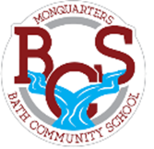
Middle School Supply List
2021 - 2022
  - a durable pencil case
  - white erasers
  - 4 packages of HB pencils
  - package of blue or black pens
  - 2 3 ring binders (1 ½ inch)
  - tab subject dividers
  - 1 pkg. of Hilroy scribblers (32-40 pages)
  - 1 sketch book
  - 1 glue stick
  - 1 set of earbuds/headphones to stay at school
  - 1 calculator with a square-root button
  - 1 box of Kleenex
  - 5 different coloured duotangs (preferably green, yellow, grey, red, blue)
  - 3 packages of loose-leaf
  - inside sneakers (must be available daily for Phys. Ed.)

